Introduction to API’s

**Application Programming Interface**

**By Eli Moser**

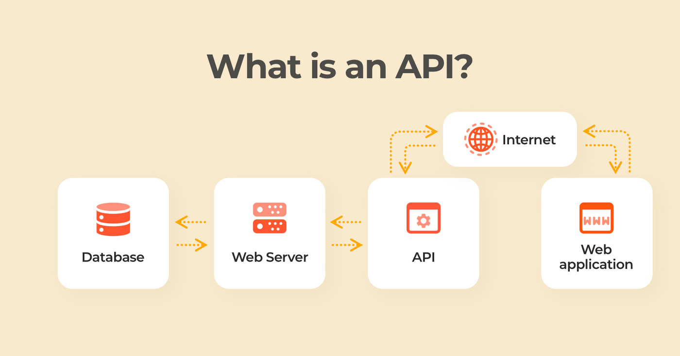

November 2021 (Ver. 1.000)

Chapter 1: Introduction 3

Chapter 2: Implementation 4

2.1 Connection Procedure 4

# Introduction

In recent years the concept of API’s is gaining popularity, you may have not noticed  
but they are literally everywhere.  
Have you ever wondered how Facebook is able to display your Instagram photos?   
How about the latest tweet from your favorite celebrity appearing in a news article?  
Or the latest price of Tesla stock appearing in an article?  
Your friend sends you his live location on a map that appears in your chat app.  
  
How is all that possible?   
  
The answer: Using an ‘Application Programming Interface’ or **API**,

Basically it’s a service that companies provide to enable people access to their information and services.

Let’s say you want to write an app or a website that provides the cheapest flights and hotels available between two dates (truly an original concept…).  
  
The way to get that information would be to manually go check for the cheapest option in all the airlines and Hotels websites and post it in our app for each search - obviously this is very time consuming and not a good option when the app becomes popular (not scalable).

Here comes the API and allows us to connect to all the service providers we want, all we need to do is send a request through the API and it will return all the information in a way we could automatically display in our app. Fantastic!

Many companies provide API’s so that customers could access their information, so Google, Facebook, Tweeter and many other service providers all have API’s and that’s how your Instagram photos could appear on Facebook.

# Implementation

This chapter describes how to communicate with the Platinum Maestro when connected, via a USB connection from a host system to allow the GMAS ports to be configured and operate via the LAN. This connection imitates a COM port connection at any available COMM Port. Therefore, if an RS232 Terminal connection is opened at the host system, udev execution opens a terminal from

Request - consists of a URL (http://…), a method (GET, POST, PUT,

DELETE), a list of headers (User-Agent…), and a body (data). Connection Procedure

The following procedure describes how to connect the host system to the Platinum Maestro via USB connection and configure the ports of the Platinum Maestro.

1. Make sure that the Platinum Maestro is powered ON.

2. Connect the USB connection from the host system to the Platinum Maestro. The PC should emit a sound signifying that a connection is made.

3. Open the Device Manager and locate the Ports section in the hierarchal structure.   
Wait a couple of minutes for the Maestro to establish a connection.

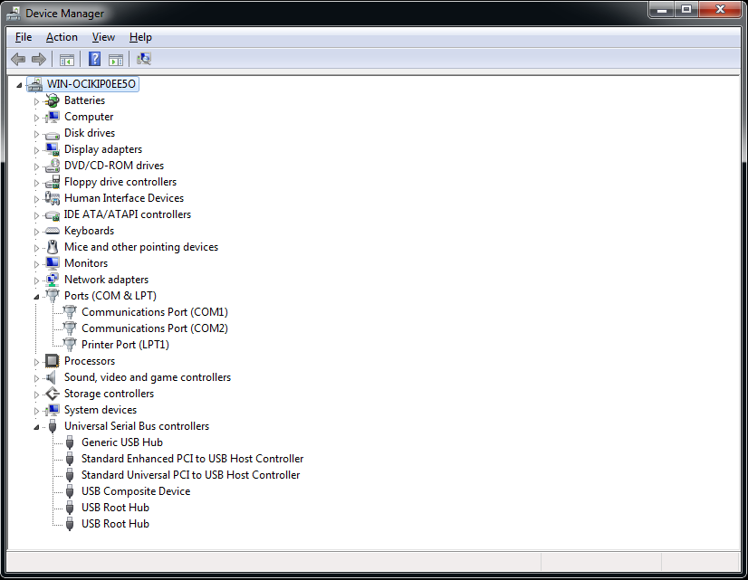

4. Click the Scan for Hardware Changes icon, or alternatively, select **Action**, and then **Scan for**